**VISVESVARAYA TECHNOLOGICAL UNIVERSITY**

**JNANA SANGAMA, BELAGAVI- 590 018**



**Report**

**on**

**Social Connect and Responsibility- BSCK307**

***Submitted in Partial Fulfillment for the Award of Degree of***

***Bachelor of Engineering***

***in***

***Computer Science Engineering***

Submitted by

Name: Akanksha Dubey

USN: 1JT23CS007

**SCR Dept. Coordinator**

Name: Dr. Jayatirtha M Patil

Designation: Assistant Professor

**NSS Programme-officer NSS Chairman**

Dr. Jayatirtha M Patil – Asst. Professor Dr. GopalaKrishna - Principal

Asst. Prof., Department of ME Professor, Department of ME

**JYOTHY INSTITUTE OF TECHNOLOGY**

**Department of Mechanical Engineering**

**Off Kanakapura Road, AgaraMain RoadTataguni**

**Bengaluru-560082**

**NON-CREDIT MANDATORY COURSE CERTIFICATE**



**This is to certify that the Social Connect Responsibility- BSCK307** has been successfully carried out by Akanksha Dubey bearing **USN: 1JT23CS007** bonafide student of **JyothyInstitute of Technology** in partial fulfillment of the requirements for the award of degree of **Bachelor of Engineering in** Dept. of **Computer Science Engineering** of **Visvesvaraya Technological University, Belagavi** during 2024-2027. It is certified that all corrections/suggestions indicated for Internal Assessment have been incorporated in the report. The **Social Connect Responsibility - BSCK307** report has been approved as it satisfies the academic requirements in respect of SCR for the said degree.

|  |  |  |  |
| --- | --- | --- | --- |
| **………………………**  **Department Coordinator**  Prof. Mr. Shrinidhi Kulkarni.  Assistant Professor | **………………………**  **College NCMC Coordinator**  Dr. Jayatirtha M Patil,  Dr. Girish,  Mr. Krishnamurthy M, | **………………………**  **Prof. &HoD,**  Dept. of Computer Science and Engineering  HoD: Dr.Prabanjan S | **…………………….…**  **Principal**  Dr. Gopalakrishna K |

### DECLARATION

I, Akanksha Dubey bearing the USN: 1JT23CS007 , student of **Bachelor of Engineering** in Dept. of **Computer Science Engineering** at Jyothy Institute of Technology, Bengaluru, hereby declare that the **Social Connect Responsibility** work has been carried out by me under the supervision and guidance of Department Staff Coordinators submitted by me as partial fulfillment for the award of Bachelor of Engineering degree in Computer Science Engineering from Visvesvaraya Technological University, Belagavi during 2023-24. I also declare that this work has not been submitted previously for the award of any degree or diploma, by me, to any institution.

**Signature of the student**

**ACKNOWLEDGEMENT**

I want to profoundly thank the Management of **Jyothy Institute of Technology** for providing me-with such a healthy environment for pursuing this work.

I am grateful to **Dr. Gopalakrishna K**, Principal, Jyothy Institute of Technology for providing me with excellent facilities and academic ambience for carrying out this work at JIT.

I express my thanks to **HoD Dr. Prabanjan S**, Prof. & HoD, **Computer Science Engineering** Dept. for **his** valuable support.

I sincerely acknowledge and thank the support extended by **Dr. Jayatirtha M Patil,** NSS Coordinator during the execution of SCR.

I am also grateful to Department NSS coordinators **Mr. Shrinidhi Kulkarni**, Programme Officer, JIT, **Dr. Girish**, Physical Education Director JIT for their valuable guidance, suggestions, and cheerful encouragement during the **SCR.**

Finally, I take this opportunity to extend my gratitude and respect to my parents, the Teaching and Technical staff of the Department and all my friends who have directly or indirectly supported me during the period of my SCR.

Content

|  |  |  |
| --- | --- | --- |
| **Sl. No.** | **Chapter Name** | **Page No.** |
| 1 | Part I: Plantation and adoption of a tree: | **6** |
| 2 | Part II : Heritage walk and crafts corner: | **10** |
| 3 | Part III : Organic farming and waste management: | **14** |
| 4 | Part IV: Water conservation: | **18** |
| 5 | Part V : Food walk: | **21** |

**Part I: Plantation and adoption of a tree:**

**Introduction to Plantation**

Plantation refers to an extensive agricultural venture where a significant expanse of land is dedicated to the cultivation of a single crop, primarily for commercial purposes. This agricultural model is characterized by the systematic cultivation of cash crops like tea, coffee, rubber, sugar, and other commodities, often in tropical or subtropical regions. Plantations are distinguished by their organized and intensive farming practices, involving large-scale cultivation, mechanized processes, and a hierarchical labor structure.

Historically, plantations have been closely linked to colonial agriculture, with European powers establishing expensive estates for the production of valuable crops through the use of forced labor, such as slaves. While modern plantations often incorporate advanced agricultural technologies and contemporary labor practices, they continue to be vital contributors to global commodity production. Plantations play a crucial role in supplying key raw materials for various industries and significantly contribute to the economies of numerous countries.

In today's context, the management and sustainability of plantations have become pivotal considerations due to their environmental impact, social responsibility, and their impact on the global economy. The ongoing efforts to balance economic profitability with environmental and social concerns underscore the evolving role and challenges associated with plantations in the contemporary world



**Growth and Development of Brahmi Plant**

**Origin:**

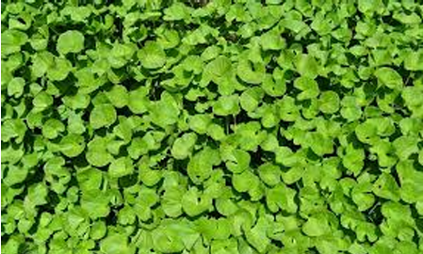

The Brahmi plant, scientifically identified as Bacopa monnieri, is a perennial herb native to wetlands and marshy areas across India, Asia, Europe, and North and South America. Flourishing in damp conditions near water bodies, it has been a significant component in traditional medicine, particularly Ayurveda, for its myriad health benefits

**Characteristics of Brahmi Plant**

* Scientific Name: *centella asiatica*
* Common Names: Brahmi, Indian Pennywort
* Habitat: Wetlands, marshes, and tropical climates
* Growth Habit: Herbaceous, creeping plant with small, succulent, oblong leaves and white or pale blue flowers.

**Growth and Development Stages**

1. **Seed Germination**
   * Brahmi is primarily propagated through stem cuttings; however, it can also grow from seeds.
   * Seeds require a moist and warm environment (20–30°C) to germinate.
   * Germination takes approximately 1–2 weeks under ideal conditions.
2. **Vegetative Growth**
   * Stem and Root Development: The plant develops creeping stems that root at the nodes when they contact soil or water.
   * Leaf Formation: Succulent, bright green leaves emerge, supporting photosynthesis and the plant's aquatic adaptations.
3. **Flowering Stage**
   * Small, solitary flowers develop within 2–3 months of growth.
   * The flowers are white or pale blue and bloom year-round in favorable climates.
4. **Maturation**
   * The plant forms dense mats of foliage and thrives in water-abundant conditions, particularly in summer or during the monsoon.

**Environmental Conditions for Growth**

* **Soil:** Prefers loamy or sandy soils enriched with organic matter. It thrives in submerged or highly moist conditions.
* **Water:** Requires consistently moist or waterlogged environments.
* **Sunlight:** Grows well in full sun to partial shade.
* **Temperature**: Thrives in tropical climates, with an optimal temperature range of 20–30°C.

**Propagation Methods**

1. **Stem Cuttings:**
   * Cut 5–10 cm sections from a healthy plant.
   * Place the cuttings in moist soil or shallow water for rooting.
   * Roots develop at the nodes within a few days to weeks.
2. **Division:**
   * Large clumps of Brahmi can be divided into smaller sections and replanted.

**Care and Maintenance**

* **Watering:** Requires consistent moisture or waterlogging.
* **Fertilization:** Benefits from organic fertilizers and compost to enhance growth.
* **Pest Management:** Generally pest-resistant, though susceptible to aphids and fungal diseases in excessively wet conditions.
* **Pruning:** Regular trimming encourages fresh growth and maintains plant health.

**Harvesting**

* Harvesting begins 3–4 months after planting.
* Leaves and stems are collected for medicinal uses, such as improving memory and reducing stress.
* The plant regenerates quickly, enabling multiple harvests annually.

**Medicinal Uses**

Brahmi is renowned for its medicinal properties, including:

* Enhancing cognitive function and memory.
* Reducing stress and anxiety.
* Treating inflammatory conditions and promoting overall health.

**Conclusion**

The Brahmi plant is a versatile and beneficial herb that thrives in tropical and semi-aquatic environments. Its ability to grow through simple propagation methods, coupled with its significant medicinal properties, makes it an essential plant in traditional medicine. Proper care, including regular watering and pruning, ensures healthy growth and development, providing a sustainable resource for both medicinal and ecological applications.



**Part II : Heritage walk and crafts corner**

A heritage walk is a guided tour that explores historically significant areas, buildings, and cultural landmarks of a city or town. It is designed to immerse participants in the history, architecture, traditions, and stories that define a particular location. Heritage walks can focus on specific themes like colonial history, ancient architecture, or the lives of prominent historical figures.

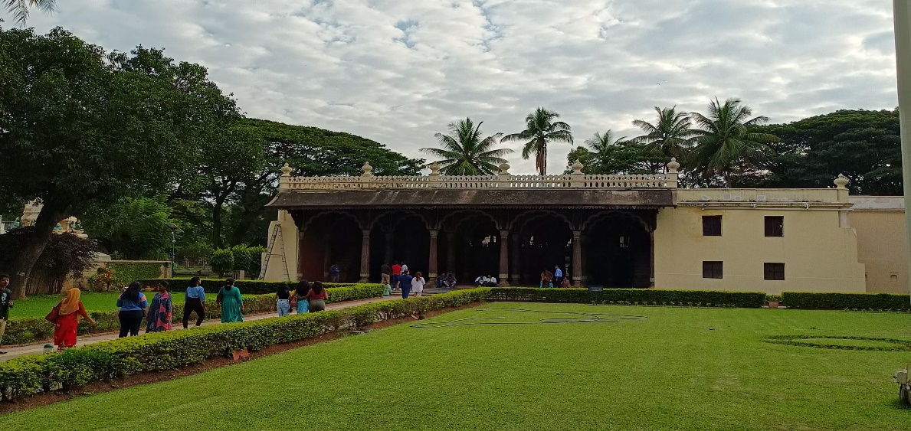

**TIPPU** **SULTHAN’S SUMMER PALACE**

**DATE OF VISIT**: 07 DECEMBER 2024

**LOCATION** : The Tipu Sultan's Summer Palace is located in Bengaluru (Bangalore), Karnataka, India. It is situated within the Bangalore Fort area in Chamrajpet, near the City Market.

Address:Tipu Sultan's Summer Palace,Albert Victor Road, Chamrajpet, Bengaluru, Karnataka 560018,India.

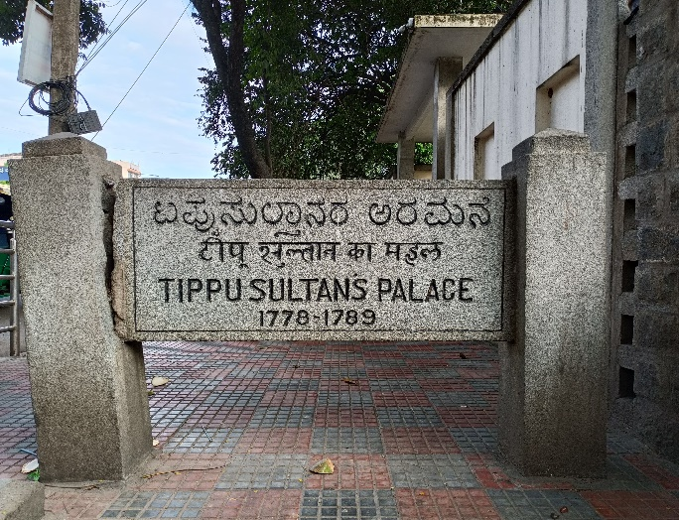

**HISTORY**:

Tipu Sultan's Summer Palace ,is a remarkable historical monument that showcases the grandeur of Mysore's 18th-century era. The palace was initially commissioned by Hyder Ali, the father of Tipu Sultan, and later completed in 1791 by Tipu himself.

The palace served as Tipu Sultan’s summer retreat and administrative headquarters. Known as the "Tiger of Mysore," Tipu Sultan was a visionary ruler, a fierce opponent of British colonialism, and a pioneer in economic and technological advancements in his kingdom. This palace stood as a symbol of his power and his contributions to the cultural and architectural heritage of the region.

During Tipu Sultan's reign, the palace witnessed many important political and administrative decisions. It also became a site for his meetings with dignitaries and foreign envoys. After Tipu Sultan's death in the Fourth Anglo-Mysore War in 1799, the palace was taken over by the British and used for administrative purposes.

**ARCHITECTURE:**

Tipu Sultan's Summer Palace in Bangalore is an exquisite example of Indo-Islamic architecture, renowned for its intricate design and elegance. Built primarily of teakwood, the palace reflects the artistic brilliance of the 18th century under Tipu Sultan’s rule.

The palace features two stories of finely crafted wooden structures with

intricately craved pillars and arches.The teak pillars are adorned with floral

motifs,highlighting the delicate craftsmanship. The symmetrical layout of the

palace,combined with the geometric patterns on the wall reflects Islamic

architectural influence.



A prominent feature of the palace is its wide open courtyard, surrounded by verandahs on all sides. These verandahs lead to chambers that were once used by Tipu Sultan and his court for administrative and leisure purposes. The central hall served as an important venue for Tipu's public meetings and gatherings.

The ceilings are beautifully painted with floral and geometric patterns, showcasing vibrant colors and intricate detailing that have survived the test of time. Ornamental balconies overlook the courtyard, giving the structure a sense of grandeur.

The palace also has several hidden chambers and passageways, adding a layer of intrigue to its design. The use of teakwood throughout the structure not only adds to its aesthetic appeal but also demonstrates the resourceful architectural practices of the era.

**SOCIO-ECONOMIC IMPACT:**

Cultural Identity:

The palace serves as a symbol of Tipu Sultan's legacy and the rich history of Karnataka, fostering a sense of pride among locals and promoting cultural awareness.

Education and Knowledge Sharing:

It acts as an educational hub, drawing students, researchers, and historians who learn about Indo-Islamic architecture, colonial history, and Tipu Sultan’s contributions.

Tourism Revenue:

The palace is a major tourist attraction in Bengaluru, generating revenue through entry fees and guided tours.

It indirectly supports the local economy by boosting demand for accommodation, transport, and food services.

Employment Opportunities:

The site creates jobs for tour guides, security personnel, maintenance staff, and artisans involved in conservation work.

Vendors selling souvenirs, crafts, and refreshments also benefit from the influx of tourists.

**CONCLUSION:** The Tipu Sultan's Summer Palace stands as a remarkable testament to the rich cultural and architectural heritage of 18th-century India. Its intricate design, historical significance, and connection to Tipu Sultan’s legacy make it an essential destination for understanding the region’s history and Indo-Islamic artistry.

The palace not only preserves the memories of a ruler who stood as a symbol of resistance and innovation but also plays a vital role in promoting heritage tourism and supporting local livelihoods. As part of a heritage walk, this site offers visitors a profound experience that blends history, art, and culture, fostering a deeper appreciation for India's diverse past.

**Part III : Organic farming and waste management:**

**Introduction to Desiri Naturals**

Desiri Naturals is a forward-thinking organization dedicated to promoting sustainable agriculture, organic farming, and environmentally friendly practices. Known for its commitment to high-quality, natural products, Desiri Naturals has made significant strides in reducing environmental impact through innovative techniques like bull-driven oil extraction and effective waste management. Their holistic approach integrates traditional methods with modern sustainability principles, setting a benchmark in the organic farming industry.

**Bull-Driven Oil Extraction Method**

At the heart of Desiri Naturals' operations is the **bull-driven oil extraction method**, a centuries-old technique that ensures the purity and nutritional value of oils. Unlike modern mechanical extraction methods that generate excessive heat and may degrade oil quality, this traditional approach offers several advantages:

* **Low-Temperature Extraction**: Ensures the retention of nutrients and essential fatty acids.
* **Chemical-Free Process**: Eliminates the need for solvents, making the oils 100% natural and safe.
* **Energy Efficiency**: Reduces dependency on electricity and fossil fuels.
* **Animal Involvement**: Utilizes bull power, promoting a connection to traditional farming and reducing mechanical waste.

This method aligns with Desiri Naturals' mission of preserving the environment while producing high-quality, chemical-free oils.

**Health and Safety Concerns in the Oil Industry**

Desiri Naturals addresses several critical health and safety concerns prevalent in the oil industry, including:

1. **Chemical Residues**:
   * Conventional oil extraction methods often involve chemical solvents that leave harmful residues in the final product.
   * Desiri's methods ensure oils are free from additives, preservatives, and toxins, making them safer for consumption.
2. **Nutritional Degradation**:
   * High heat used in modern extraction destroys essential vitamins and antioxidants.
   * Desiri’s cold-pressed techniques retain maximum nutritional content.
3. **Environmental Hazards**:
   * Industrial oil extraction generates waste and pollution.
   * Desiri's traditional methods minimize environmental damage, emphasizing a cleaner and greener approach.

**Social Impact and Sustainable Practices**

Desiri Naturals takes a socially responsible approach to its operations, ensuring a positive impact on both local communities and the environment:

1. **Empowering Farmers**:
   * The company works closely with local farmers, providing training and resources to adopt organic farming techniques.
   * By offering fair pricing, Desiri supports farmers' livelihoods and promotes sustainable agriculture.
2. **Reducing Carbon Footprint**:
   * The bull-driven oil extraction method drastically reduces energy consumption and greenhouse gas emissions.
   * This aligns with global sustainability goals and helps combat climate change.
3. **Promoting Biodiversity**:
   * By encouraging organic farming, Desiri Naturals helps preserve soil fertility and promotes biodiversity in farming ecosystems.
4. **Community Engagement**:
   * The organization actively engages with communities to spread awareness about the benefits of organic products and eco-friendly practices.
   * Workshops and campaigns educate consumers about sustainable living and healthy eating habits.

**Waste Management Strategies**

Desiri Naturals integrates effective waste management practices into its operations to ensure sustainability:

1. **Reuse of Byproducts**:
   * Oilcake, a byproduct of the extraction process, is repurposed as organic fertilizer or cattle feed.
   * This ensures zero waste while supporting agricultural productivity.
2. **Composting**:
   * Organic waste generated during farming is composted and returned to the soil, enhancing fertility and reducing landfill waste.
3. **Water Conservation**:
   * Desiri employs techniques like rainwater harvesting and minimal water usage during processing.
4. **Plastic Reduction**:
   * The company uses biodegradable or reusable packaging materials to minimize plastic waste.

**Innovation in Organic Farming**

Desiri Naturals has introduced several innovative practices to enhance organic farming efficiency:

* **Crop Rotation and Companion Planting**: Promotes soil health and natural pest control.
* **Natural Pest Management**: Utilizes herbal sprays and biological control methods instead of chemical pesticides.
* **Seed Preservation**: Collaborates with local farmers to preserve indigenous seed varieties.

**Consumer Awareness and Education**

Desiri Naturals takes pride in educating consumers about:

* The health benefits of organic products.
* The environmental advantages of choosing sustainable brands.
* The importance of supporting traditional farming methods.

The company conducts regular workshops, social media campaigns, and community programs to spread its message.

**Future Goals and Vision**

Desiri Naturals aims to expand its reach while staying true to its core values of sustainability and quality:

* **Expanding Product Range**: Introducing more organic products to meet diverse consumer needs.
* **Global Outreach**: Promoting traditional Indian farming methods and organic products in international markets.
* **Enhanced Waste Management**: Investing in advanced, eco-friendly technologies to further minimize waste.
* **Community Development**: Increasing support for rural farmers through education, financial aid, and infrastructure development.

**Conclusion**

Desiri Naturals exemplifies how a blend of traditional wisdom and modern sustainability practices can create a healthier, more sustainable future. Through initiatives like bull-driven oil extraction and comprehensive waste management, the company has set a high standard for environmentally conscious operations. Its focus on organic farming, community engagement, and consumer education ensures a lasting impact on health, society, and the planet. Desiri Naturals is not just a business but a movement towards a more sustainable and organic world.

4o

Top of Form

Bottom of Form

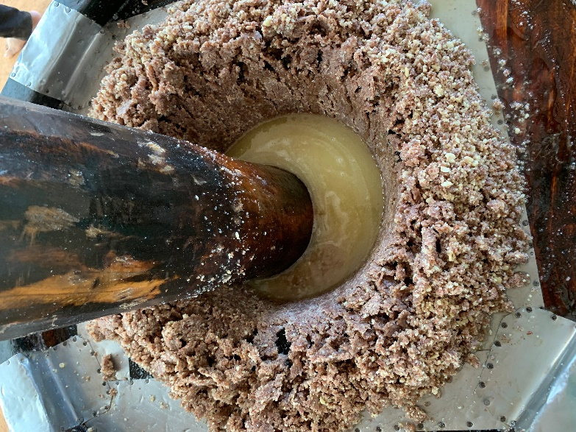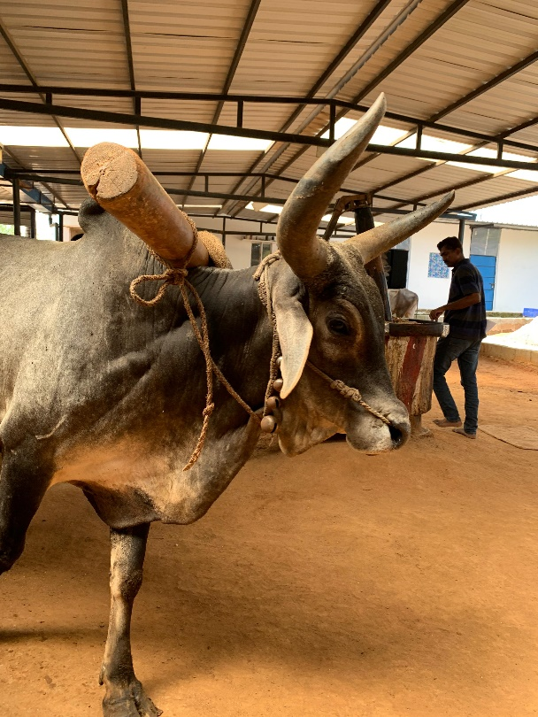

**Part IV: Water conservation:**

**Introduction**

Water is the lifeblood of our planet, essential for survival and development. However, with increasing demand and depleting resources, water scarcity has emerged as a significant global concern. Addressing this challenge requires immediate action, especially from young minds, who can champion the cause of conservation. This report explores water conservation, its significance for the future, and how students can contribute to this mission.



**Understanding Water Conservation**

Water conservation involves managing and using water resources efficiently to reduce wastage and ensure sustainability. It includes practices like rainwater harvesting, wastewater recycling, and promoting water-saving habits. Effective water conservation maintains the delicate balance of our ecosystems and ensures equitable access to water for all.

**Why Students Must Learn About Water Conservation**

1. **Shaping Future Leaders**: Students are the decision-makers of tomorrow. Awareness at an early age fosters responsible habits.
2. **Promoting Awareness**: Youth can spread knowledge within their families and communities.
3. **Sustainability Advocates**: Students can influence future policies and practices through education and action.

**Importance of Water Conservation for the Future**

1. **Ensuring Water Availability**: With growing populations, conserving water today safeguards resources for tomorrow.
2. **Environmental Balance**: Conserving water helps maintain natural ecosystems and biodiversity.
3. **Mitigating Climate Change**: Efficient water use reduces energy consumption, which in turn minimizes greenhouse gas emissions.

**How Students Can Contribute to Water Conservation**

1. **Practicing Responsible Usage**: Avoiding wastage by turning off taps, using buckets instead of hoses, and fixing leaks.
2. **Participating in Activities**: Joining water conservation clubs or campaigns in schools.
3. **Learning Sustainable Practices**: Implementing rainwater harvesting or using recycled water for gardening.
4. **Educating Others**: Sharing knowledge with friends, family, and community members.

**Methods of Awareness Campaigns**

1. **Workshops and Seminars**: Hosting sessions to educate peers on water conservation techniques.
2. **Social Media Initiatives**: Using platforms like Instagram, YouTube, or Twitter to spread awareness.
3. **Competitions**: Organizing poster-making, debates, or essay-writing contests on water conservation.
4. **Community Drives**: Conducting clean-up activities and demonstrating water-saving methods in local areas.

**Observations Made During the Campaign**

1. **Positive Engagement**: Students displayed enthusiasm in learning and adopting water-saving practices.
2. **Increased Awareness**: Campaigns helped debunk myths about water abundance.
3. **Community Participation**: Local residents were inspired to adopt sustainable habits.
4. **Challenges**: Limited infrastructure for rainwater harvesting and water recycling in schools.

**Key Learnings and Conclusions**

1. **Awareness Is Key**: Knowledge is the first step in changing behaviors and attitudes.
2. **Collective Action**: Collaboration amplifies the impact of conservation efforts.
3. **Youth Potential**: Students have the power to become effective advocates for sustainability.
4. **Sustainable Practices Are Necessary**: Adopting long-term solutions is essential to combat water scarcity.

**Recommendations for Future Initiatives**

1. **Introduce Water Conservation Modules**: Include water conservation as part of the school curriculum.
2. **Infrastructure Development**: Install rainwater harvesting and water recycling systems in schools.
3. **Regular Awareness Drives**: Organize frequent workshops and community programs.
4. **Collaboration with NGOs**: Partner with organizations specializing in water conservation to enhance campaign effectiveness.
5. **Monitoring and Feedback**: Develop a system to measure the impact of campaigns and seek suggestions for improvement.

**Conclusion**

Water conservation is a shared responsibility that begins with individual actions and grows through collective efforts. Students, as future custodians of the planet, play a pivotal role in shaping a sustainable future. Through awareness, education, and active participation, we can overcome water scarcity challenges and ensure that water remains a resource for all generations to come.

**Part V : Food walk: Karnataka Bhel House**

**Introduction**



Karnataka Bhel House, located in the bustling locality of Chamarajpet, Bangalore, is a beloved landmark for food lovers. Specializing in a variety of traditional and innovative chaat dishes, it has been serving delicious street food for decades. Known for its unique fusion of South and North Indian culinary flavors, this establishment has become a go-to spot for locals and visitors seeking authentic, flavorful snacks.

**2. History and Legacy**

Karnataka Bhel House has a long-standing reputation in Bangalore’s food scene. Established many years ago, the eatery has built a loyal customer base due to its distinctive recipes and dedication to quality. The fusion of Karnataka’s spicy flavors with traditional North Indian chaat has made it stand out from other eateries in the area. The establishment is a part of Chamarajpet’s vibrant food culture, drawing in crowds who return for the nostalgic taste and experience.

**3. Menu and Specialties**

Karnataka Bhel House is known for its wide range of street food offerings. The menu features a mix of traditional North Indian chaats with a twist of South Indian spices. Here are some of the most popular items:

1. **Special Bhel Puri**: A tangy and crunchy snack made with puffed rice, sev, potatoes, and a blend of spices. The special chutneys give it a unique flavor.
2. **Masala Puri**: Crispy puris topped with a spicy mixture of mashed potatoes, chutneys, and a sprinkle of sev.
3. **Nippat Masala**: A crispy puffed rice dish topped with tangy masala, offering a delightful crunch and spice.
4. **Pani Puri**: Fresh puris filled with spicy tamarind water and a blend of flavorful fillings.
5. **Khara Mandakki**: A spicy version of puffed rice mixed with peanuts, onions, and spices.

Each dish is carefully crafted to provide a burst of flavors, making it a hit among the visitors.

**4. Cultural Significance**

Karnataka Bhel House is more than just a place to eat; it represents a blend of local culture and food traditions. The dishes served here are a fusion of North Indian chaat and South Indian flavors, symbolizing the multicultural food scene in Bangalore. The eatery’s impact goes beyond serving food—it has become a part of local memories and culture.

* **Local Favorite**: The dishes have become favorites among locals, many of whom have been visiting Karnataka Bhel House for years. The establishment has earned its place as a significant part of the area’s food history.
* **Street Food Heritage**: Karnataka Bhel House plays an important role in preserving the street food culture of Bangalore, serving dishes that are both accessible and representative of the city’s culinary diversity.

**5. Ambience and Experience**

The atmosphere at Karnataka Bhel House is lively, with a continuous stream of customers enjoying their meals. The casual, no-frills setting allows visitors to focus on what truly matters—tasting the delicious food. The small seating area encourages a community feel, as regulars and first-time visitors alike share tables and enjoy the bustling food culture.

**6. Popularity and Customer Feedback**

Karnataka Bhel House enjoys immense popularity due to its reputation for consistent taste, quality ingredients, and the value it offers. Many customers return to the place for its nostalgic appeal and the chance to relive fond memories of their past visits. Feedback from customers highlights:

* **Flavor**: The distinctive balance of spices in each dish is a major draw.
* **Affordability**: The food is reasonably priced, making it an attractive option for students, professionals, and families.
* **Quick Service**: Despite the crowds, the service remains efficient, ensuring that customers don’t have to wait long for their food.

**7. Conclusion**

Karnataka Bhel House in Chamarajpet continues to be a beloved spot for food lovers in Bangalore. Its combination of traditional chaat and innovative South Indian flavors has earned it a lasting place in the city’s culinary history. The eatery not only serves food but also nurtures a sense of community, where people of all ages come together to enjoy the rich flavors and vibrant atmosphere. Whether you’re a local or a visitor, Karnataka Bhel House promises an unforgettable street food experience that will keep you coming back for more.

